**IDEATION PHASE**

**Define the Problem Statements**

|  |  |
| --- | --- |
| **NAME** | **DINESH M** |
| **TEAM ID** | **8E2B4970F2F803A9B084E092E573C2AC** |
| **PROJECT NAME** | **Creating a sponsored post for Instagram** |

**Customer Problem Statement Template:**

Create a problem statement to understand your customer's point of view. The Customer Problem Statement template helps you focus on what matters to create experiences people will love.

A well-articulated customer problem statement allows you and your team to find the ideal solution for the challenges your customers face. Throughout the process, you’ll also be able to empathize with your customers, which helps you better understand how they perceive your product or service.

**THE PROBLEM STATEMENT IN CREATING A SPONSORED POST FOR INSTAGRAM**

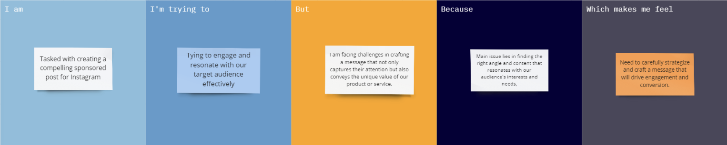

**REFERENCE LINK:**

<https://miro.com/app/board/uXjVMLRn6Jo=/?share_link_id=61727472141>

The various problem statements are defined by the various persons related to workers health and safety are tabulated below:

|  |  |  |  |  |  |
| --- | --- | --- | --- | --- | --- |
| **Problem Statement (PS)** | **I am (Customer)** | **I’m trying to** | **But** | **Because** | **Which makes me feel** |
| PS-1 | Sponsored post creator | Engage and resonate with our target audience effectively | I am facing challenges in crafting a message that not only captures their attention but also conveys the unique value of our product or service | The main issue lies in finding the right angle and content that resonates with our audience's interests and needs | the need to carefully strategize and craft a message that will drive engagement and conversion. |

**EMPATHY MAP**

|  |  |
| --- | --- |
| **NAME** | **M.DINESH** |
| **NM ID** | **8E2B4970F2F803A9B084E092E573C2AC** |
| **PROJECT NAME** | **Creating a sponsored post for Instagram** |

**Empathy map link**

<https://app.mural.co/t/landingpage4369/m/landingpage4369/1698486759674/452bf4aaf66c0b0336b0bd0d0342d1b6f5b81aa7?sender=u83846649c59736fc18bc0774>

**PDF:**

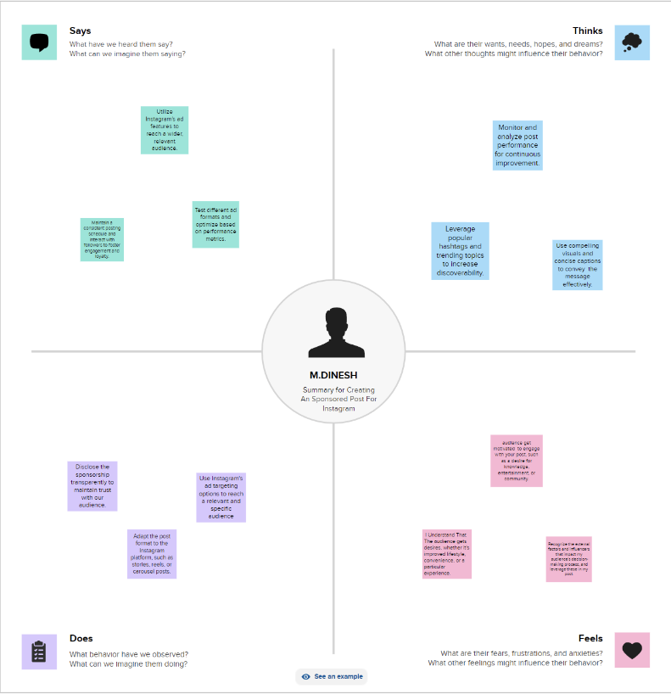

**BRAINSTORMING AND IDEA PRIORITIZATION**

|  |  |
| --- | --- |
| **NAME** | **M DINESH** |
| **NM ID** | **8E2B4970F2F803A9B084E092E573C2AC** |
| **Project Title** | **Creating a sponsored post for instagram** |

**Page Link:**

[**https://app.mural.co/t/dineshm7125/m/dineshm7125/1698943115648/69be1deddf507fbc8efffbad890a68f7d3301a1f?sender=u9c9726e9c962ccd47ed74340**](https://app.mural.co/t/dineshm7125/m/dineshm7125/1698943115648/69be1deddf507fbc8efffbad890a68f7d3301a1f?sender=u9c9726e9c962ccd47ed74340)

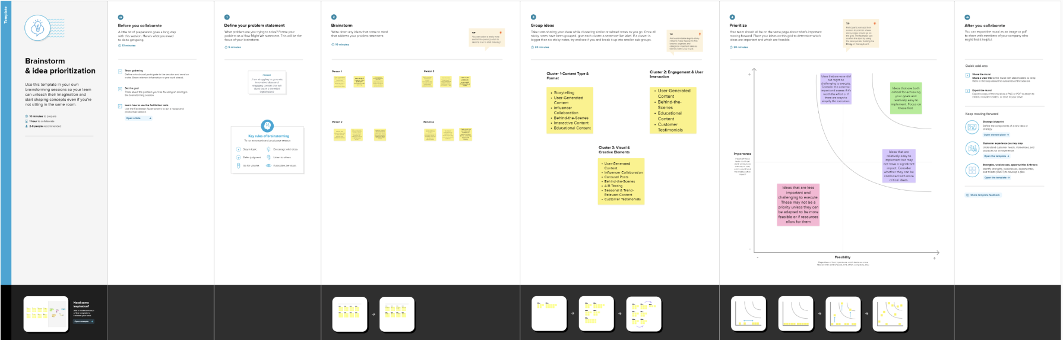

**Project Design Phase-I**

**Proposed Solution Template**

|  |  |
| --- | --- |
| **NAME** | **M.DINESH** |
| **NM ID** | **8E2B4970F2F803A9B084E092E573C2AC** |
| **PROJECT NAME** | **Creating a sponsored post for Instagram** |

**Proposed Solution Template:**

|  |  |  |
| --- | --- | --- |
| **S.No.** | **Parameter** | **Description** |
| 1 | Solution Architecture | Describe the high-level architecture of your solution, covering the following areas:  **Front-End**  Explain the technologies and frameworks you'll use for the user interface. This might include React, Vue, or any other suitable front-end technology.  **Back-End**  Detail the back-end infrastructure, including the programming language, framework, and any relevant databases or APIs. For instance, you might mention Node.js with Express.js and a PostgreSQL database.  **Hosting and Deployment**  Outline your approach to hosting and deployment, including whether you'll use a cloud platform like AWS, Google Cloud, or a shared hosting service.. |
| 2 | Functional Features | List the key functional features of your solution, including user authentication, content creation, content scheduling, hashtag management, audience targeting, analytics, payment processing, and feedback/reporting. |
| 3 | Technical Stack | Provide a breakdown of the technical stack you plan to use, including specific tools, libraries, and frameworks for both front-end and back-end development. |
| 4 | Security and Privacy Considerations: | Implement robust security measures to protect user data and privacy.  Comply with relevant data protection and privacy regulations. |
| 5 | Scalability and Performance: | Design the system with scalability in mind to handle a growing user base and increasing post volume. |
| 6 | User Training and Support: | Offer training materials and responsive customer support to assist users in making the most of the platform. |

This proposed solution outlines the project's key features, technology stack, development phases, and considerations for security, scalability, and user support. It's important to keep the project's goals in mind while implementing this solution and continuously iterate based on user feedback and evolving industry trends.

**Project Design Phase-I**

**Solution Architecture**

|  |  |
| --- | --- |
| **NAME** | **M.DINESH** |
| **NM ID** | **8E2B4970F2F803A9B084E092E573C2AC** |
| **PROJECT NAME** | **Creating a sponsored post for Instagram** |

**Solution Architecture:**

Solution architecture is a complex process – with many sub-processes – that bridges the gap between business problems and technology solutions. Its goals are to:

● Find the best tech solution to solve existing business problems.

● Describe the structure, characteristics, behaviour, and other aspects of the software to project stakeholders.

● Define features, development phases, and solution requirements.

● Provide specifications according to which the solution is defined, managed, and delivered.

**Solution Architecture for sponsored post on instagram**

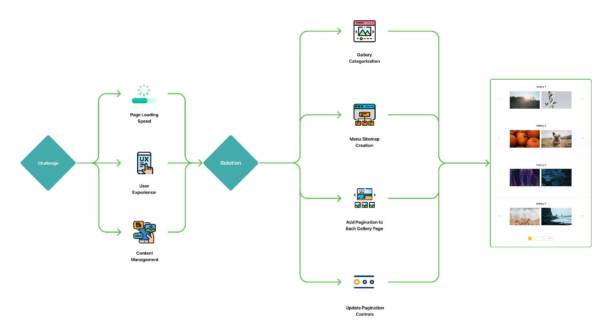

Designing the solution architecture for "Creating a Sponsored Post for Instagram" involves defining the overall structure, components, and interactions of the system. Here's a high-level solution architecture for such a project:

1. **User Interface (UI):**

Web Application: The user interacts with the platform through a web application that provides a user-friendly interface for creating and managing sponsored posts.

1. **Front-end:**

* **Front-end Framework:** Utilize a modern JavaScript framework like React, Vue.js, or Angular for building the user interface.
* **User Authentication:** Implement user authentication for secure access to the platform.
* **Content Creation:** Allow users to create, design, and schedule sponsored posts using a user-friendly interface.
* **Hashtag Management:** Provide tools for users to manage and select relevant hashtags.
* **Audience Targeting:** Incorporate features to define and target specific audience segments.
* **Analytics Dashboard:** Create a dashboard for users to monitor post performance, engagement, and reach.
* **Payment Integration:** Implement secure payment processing for businesses to promote posts.

3. **Back-end:**

* **Back-end Framework:** Use a server-side framework like Node.js, Ruby on Rails, Django, or Spring Boot.
* **API Layer:** Develop RESTful APIs to handle user requests for tasks such as post creation, scheduling, analytics, and user management.
* **User Authentication:** Implement user authentication on the server-side to ensure secure access.
* **Database:** Utilize a database management system (e.g., PostgreSQL, MongoDB) to store user data, post information, and analytics data.
* **Instagram API Integration**: Integrate with the Instagram API to enable post scheduling, data retrieval, and interactions with Instagram features.
* **Payment Processing**: Implement secure payment processing, if required, to allow businesses to promote posts.
* **Security Layer**: Implement security measures, including data encryption, access controls, and protection against common web vulnerabilities.
* **Scalability**: Design the back-end to be scalable and capable of handling a growing user base.

4. **Database:**

* **User Data Storage:** Store user account information, profiles, and preferences.
* **Post Data Storage:** Save sponsored post content, scheduling information, and associated data.
* **Analytics Data:** Store post performance metrics, engagement data, and user interactions.

**5. Cloud Hosting:**

* Host the application on a cloud platform (e.g., AWS, Google Cloud, Azure) for scalability, reliability, and ease of management.
* Use cloud resources to handle varying levels of traffic and to ensure high availability.

**6. External Integrations:**

Integrate with third-party services, such as payment gateways, email services, and social media APIs, as needed.

**7. Monitoring and Analytics:**

* Implement tools and services for monitoring the application's performance, security, and user interactions.
* Set up analytics to gather data on user behavior and post performance

.

**8. Security and Privacy Considerations:**

Ensure that the architecture complies with relevant data protection and privacy regulations.

Implement security measures to protect user data, payments, and overall system integrity.

**9. Continuous Improvement:**

Establish processes for collecting user feedback and making continuous improvements to the platform.

**10. Load Balancing and Scaling:**

Implement load balancing to evenly distribute incoming traffic across multiple server instances.

Design the system to be scalable, allowing for efficient resource allocation as the user base grows.

**11. Disaster Recovery:**

Set up backup and disaster recovery solutions to ensure data integrity and business continuity.

This architecture provides a high-level view of how the components of the system interact to create a sponsored post for Instagram. Depending on specific project requirements and technologies chosen, the architecture can be adapted and expanded to meet the project'sunique needs..

**Project Design Phase-II**

**Determine The Requirements (Customer Journey Maps)**

|  |  |
| --- | --- |
| **NAME** | **M.DINESH** |
| **NM ID** | **8E2B4970F2F803A9B084E092E573C2AC** |
| **PROJECT NAME** | **Creating a sponsored post for instagram** |

Key steps for creating a sponsored post for instagram with a focus on incorporating customer journey mapping

:

**Stage 1: Awareness**

User Persona Identification: Understand your target audience, including demographics, interests, and pain points.

**User Pain Points:** Identify the challenges or needs your audience has regarding sponsored posts on Instagram.

**Stage 2: Research and Planning**

* **Content Strategy**: Define the type of content that resonates with your audience and aligns with your brand.
* **Platform Selection**: Determine which Instagram features (e.g., stories, carousel, IGTV) best suit your content strategy.

**Stage 3: Content Creation**

* **Design Tools:** Choose design tools or software for creating visually appealing content.
* **Content Scheduling**: Plan content creation in advance and establish a posting schedule.
* **Branding Elements:** Ensure your brand identity (colors, logos, style) is incorporated into the content.

**Stage 4: Posting and Engagement**

* **Post Creation:** Develop Instagram posts that are engaging, relevant, and visually appealing.
* **Engagement Strategy**: Define how you will interact with the audience through comments, likes, and direct messages.
* **Hashtag Strategy**: Create a strategy for using relevant hashtags to expand the post's reach.

**Stage 5: Monitoring and Analytics**

* **Performance Tracking:** Use Instagram Insights or third-party analytics tools to monitor post performance.
* **KPIs:** Define key performance indicators (KPIs) to measure the success of your sponsored posts, such as reach, engagement, and conversion rates.

**Stage 6: Adaptation and Optimization**

* **Data Analysis:** Analyze the collected data to understand what works and what doesn't.
* **Content Iteration:** Based on the data, iterate and improve your content strategy.

**Stage 7: Conversion and ROI**

* **Conversion Path:** Create clear calls to action (CTAs) that guide users toward the desired action, whether it's visiting a website, making a purchase, or subscribing.
* **ROI Calculation**: Assess the return on investment to determine the effectiveness of your sponsored posts.

**Stage 8: Customer Feedback and Loyalty**

* **User Feedback:** Collect feedback from users to understand their experience and expectations.
* **Loyalty Programs:** Develop loyalty programs or incentives to keep customers engaged and coming back.

**Stage 9: Continuous Improvement**

* **Content Calendar Updates**: Maintain an up-to-date content calendar that aligns with user preferences and seasonal trends.
* **Adaptation to Algorithm Changes:** Stay informed about Instagram's algorithm updates and adjust strategies accordingly.
* **Emerging Trends:** Keep an eye on emerging trends in Instagram marketing and incorporate them into your strategy.

**Project design phase-II**

**Requirement Analysis (Functional, Operational, Technical) / Flow Charts**

|  |  |
| --- | --- |
| **TEAM LEAD** | **M.DINESH** |
| **NM ID** | **8E2B4970F2F803A9B084E092E573C2AC** |
| **PROJECT NAME** | **Creating a sponsored post for Instagram** |

**FUNCTIONAL REQUIREMENTS**

|  |  |  |
| --- | --- | --- |
| **S.NO** | **Functional Requirements** | **Requirement Description** |
| 1. | User Authentication: | Users should be able to log in using their Instagram accounts. |
| 2. | Content Creation | Users can create and design Instagram posts with images, captions, and other elements. |
| 3. | Content Scheduling: | The ability to schedule posts to be published at a specified date and time. |
| 4. | Hashtag Management: | Users can select and manage relevant hashtags for their posts.. |
| 5. | Analytics: | Users can access post performance metrics like likes, comments, and engagement.. |
| 6. | Payment Processing: | If applicable, the system should support payment for sponsored posts. |

**OPERATIONAL REQUIREMENTS**

|  |  |  |
| --- | --- | --- |
| **S.NO** | **Operational Requirements** | **Requirement Description** |
| 1. | Uptime and Reliability: | The system should be available and reliable during peak usage times. |
| 2. | Scalability: | : The ability to handle an increasing number of users and posts. |
| 3. | Data Privacy and Security: | Ensuring user data and content are secure and comply with privacy regulations |
| 4. | Support and Maintenance: | Plan for regular updates, maintenance, and testing. |
| 5. | User Training: | Align the landing page with the overall content strategy. |

|  |  |  |
| --- | --- | --- |
| **S.NO** | **Technical Requirements** | **Requirement Description** |
| 1. | **PlatFORM** | The system must be compatible with Instagram's API and interface. |
| 2. | **Database**: | Selection of an appropriate database for storing user data and post content. |
| 3. | **HostinG Environment**: | Whether the project will be hosted on a cloud platform or dedicated servers |
| 4. | **Programming Language**: | The choice of programming languages and frameworks for development. |
| 5. | **API Integration**: | Integration with Instagram's API for post scheduling and analytics. |
| 6. | **Security Measures**: | Implementing encryption, access controls, and other security measures.. |

**TECHNICAL REQUIREMENTS**

**FLOW CHARTS**

Analytics (Feedback and reporting)

Content Scheduling(Payment Processing)

Hashtag Selection(Target Audience)

User authentication(Content creation)

**Project Design Phase-II**

**Technical Architecture**

|  |  |
| --- | --- |
| **NAME** | **M.DINESH** |
| **NM ID** | **8E2B4970F2F803A9B084E092E573C2AC** |
| **PROJECT NAME** | **Creating a sponsored post for Instagram** |

**Technical Architecture for creating a sponsored post for instagram**

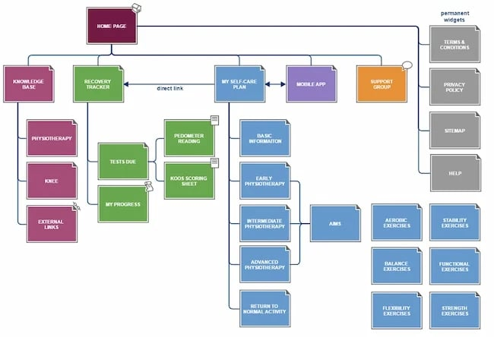

Creating a technical architecture for a project like "Creating a Sponsored Post for Instagram" involves designing a scalable, secure, and efficient system to handle user authentication, content creation, scheduling, analytics, and other essential functions. Below is a high-level technical architecture for this project:

**1. Front-end Application:**

**React.js:** Use React for building the user interface. React is a popular and efficient library for creating dynamic and interactive web applications.

2**. Back-end Server:**

**Node.js with Express.js**: Node.js provides a non-blocking, event-driven architecture that is ideal for handling a high volume of requests. Express.js is a minimal and flexible Node.js web application framework that simplifies API development.

**3. Database:**

**Relational Database Management System (RDBMS):** Choose an RDBMS like PostgreSQL or MySQL to store user data, post content, and analytics data. This is important for maintaining data consistency and reliability.

**4. Instagram API Integration:**

Integrate with the Instagram Graph API for features like user authentication, post scheduling, and post analytics. This allows your application to interact with Instagram's platform.

**5. Content Delivery:**

Use a content delivery network (CDN) to serve images and media content efficiently to users. A CDN helps reduce load times and ensures a seamless user experience.

6**. Security Layer:**

Implement security measures to protect user data and application integrity. This includes user authentication, data encryption, and secure communication with the Instagram API.

**7. Load Balancer:**

Employ a load balancer to evenly distribute incoming traffic across multiple server instances. This ensures high availability and reliability of the application.

**8. Caching Layer:**

Use caching mechanisms (e.g., Redis) to store frequently accessed data, such as user profiles and frequently used hashtags. Caching helps reduce database load and improves response times.

**9. Payment Gateway Integration (Optional):**

If the application supports payment processing for sponsored posts, integrate with a payment gateway provider to handle transactions securely.

**10. Application Logic:**

Develop the core application logic, including user account management, content creation, scheduling, and analytics tracking. Ensure that business rules and algorithms are efficiently implemented.

**11. API Layer:**

Design RESTful API endpoints for client-server communication. These endpoints should facilitate actions like creating posts, scheduling, and accessing analytics.

**12. Analytics and Reporting:**

Implement tools and libraries to collect and analyze user engagement and post performance data. Use a dedicated database or data warehouse for storing analytics data.

**13. Monitoring and Logging:**

Set up monitoring tools like Prometheus or New Relic to track system performance and detect issues in real time. Implement comprehensive logging to aid in debugging and auditing.

**14. Continuous Integration/Continuous Deployment (CI/CD):**

Utilize CI/CD pipelines for automated testing and deployment, ensuring that code changes are thoroughly tested and deployed seamlessly.

**15. Scalability and Cloud Hosting:**

Deploy the application on a cloud platform (e.g., AWS, Google Cloud, Azure) to leverage scalability features and easily handle increasing user loads. Configure auto-scaling based on traffic patterns.

**16. Data Privacy and Compliance:**

Ensure that the system complies with data privacy regulations and industry standards, such as GDPR or HIPAA, depending on the scope and nature of the project.

**17. User Training and Support:**

Provide training materials and a support system for users to navigate the platform effectively.

This technical architecture outlines the components and technologies needed to build a Sponsored Post for Instagram application. It's important to follow best practices for security, performance, and scalability while continuously monitoring and optimizing the system for an optimal user experience.

**Project Design Phase-II**

**OPEN SOURCE FRAMEWORKS**

|  |  |
| --- | --- |
| **TEAM LEAD** | **M.DINESH** |
| **NM ID** | **8E2B4970F2F803A9B084E092E573C2AC** |
| **PROJECT NAME** | **Creating a sponsored post for instagram** |

When developing a project for creating sponsored posts on Instagram, you can take advantage of various open-source frameworks and libraries to streamline your development process. These frameworks offer pre-built components and functionalities that can help you save time and resources. Here are some open-source frameworks and tools you can consider:

**React:**

* **Description:** A popular JavaScript library for building user interfaces. It can be used for creating the user interface of your sponsored post management application.
* **Website:** React

**Node.js:**

* **Description:** A server-side JavaScript runtime that can be used to build the backend of your application. You can create API endpoints for managing posts and user accounts.
* **Website:** Node.js

**Express.js:**

* **Description:** A minimal and flexible Node.js web application framework that simplifies the creation of robust APIs.
* **Website:** Express.js

**Python Django:**

* **Description:** A high-level Python web framework that can be used to build the backend of your application, handling user authentication and more.
* **Website:** Django

**Flask:**

* **Description:** A micro web framework for Python, which is well-suited for creating lightweight APIs or backend services.
* **Website:** Flask

**Ruby on Rails:**

* **Description:** A popular web application framework for Ruby, suitable for building web applications and APIs.
* **Website:** Ruby on Rails

**Vue.js:**

* **Description:** A progressive JavaScript framework for building user interfaces. It can be an alternative to React for the frontend of your application.
* **Website**: Vue.js

**Laravel:**

* **Description: A** PHP web application framework that is great for building feature-rich web applications and APIs.
* **Website:** Laravel

**Spring Boot**:

* **Description**: A Java-based framework that simplifies the development of web applications and APIs. It's known for its ease of use and robustness.
* **Website:** Spring Boot

**Ruby Grape:**

* **Description:** A lightweight and fast API framework for Ruby that can be used to build RESTful APIs.
* **Website:** Grape

**Flask-RESTful:**

* **Description:** An extension for Flask that simplifies the creation of RESTful APIs in Python.
* **Website:** Flask-RESTful

**PostgreSQL:**

* **Description:** An open-source relational database management system that can be used to store user data, post information, and more.
* **Website:** PostgreSQL

**MongoDB:**

* **Description:** A NoSQL database that is suitable for handling unstructured data, making it an option for certain data storage needs in your project.
* **Website:** MongoDB

**Coding:**

**Front-end (React):**

Assuming you have a React application set up, here's a simple component for creating a sponsored post:

import React, { useState } from 'react';

function CreateSponsoredPost() {

const [postContent, setPostContent] = useState('');

const handlePostContentChange = (e) => {

setPostContent(e.target.value);

};

const handlePostSubmission = () => {

// Handle the submission, e.g., send postContent to the server

};

return (

<div>

<h1>Create a Sponsored Post</h1>

<textarea

placeholder="Write your post here..."

value={postContent}

onChange={handlePostContentChange}

/>

<button onClick={handlePostSubmission}>Create Post</button>

</div>

);

}

export default CreateSponsoredPost;

**Project Design Phase-II**

**Third-Party API’s**

|  |  |
| --- | --- |
| **NAME** | **M.DINESH** |
| **NM ID** | **8E2B4970F2F803A9B084E092E573C2AC** |
| **PROJECT NAME** | **Creating a sponsored post for Instagram** |

When developing a project for creating sponsored posts on Instagram, you might consider integrating with various third-party APIs to enhance your application's functionality and provide more features to your users. Here are some third-party APIs you can consider integrating into your project:

**Instagram Graph API:**

Official Instagram API for interacting with Instagram's platform, enabling features like user authentication, post scheduling, and analytics tracking.

**Payment Gateway APIs:**

Payment gateway APIs like PayPal, Stripe, or Square can be integrated to facilitate secure payment processing for businesses looking to promote their posts.

**Content Delivery Network (CDN) APIs:**

CDN services such as Amazon CloudFront or Cloudflare provide APIs to deliver images and media content efficiently to users, enhancing content load times.

**Hashtag Analytics APIs:**

Consider integrating with APIs that provide hashtag analytics and tracking, helping users select and manage relevant hashtags for their posts.

**Google Analytics API:**

Integrate Google Analytics to track user behavior, conversions, and other analytics data related to your platform.

**Social Media Management Tools APIs:**

APIs from tools like Hootsuite or Buffer can be used to streamline social media management, including scheduling posts across various platforms.

**Image Editing APIs:**

APIs like Cloudinary or Imgix can provide image processing and editing features to enhance the images used in sponsored posts.

**User Authentication and Authorization APIs:**

Services like Auth0 or Okta can be used to streamline user authentication and authorization, ensuring a secure login experience.

**Geolocation APIs:**

If your platform involves location-based features, you can integrate geolocation APIs like Google Maps for location tagging and targeting.

**Machine Learning and AI APIs:**

Implement image recognition and sentiment analysis by integrating with machine learning and AI APIs like Google Cloud Vision or Microsoft Azure Cognitive Services.

**Email and Notification APIs:**

Utilize email and notification APIs like SendGrid or Twilio for email notifications and SMS alerts.

**Data Analytics and Business Intelligence APIs:**

Implement data analytics and business intelligence features by integrating with APIs like Tableau or Power BI.

**Reporting and Data Visualization APIs:**

Use APIs such as D3.js for custom data visualization or reporting capabilities within your application.

**Legal Compliance and Data Privacy APIs:**

Integrate with services like OneTrust or TrustArc to manage legal compliance and data privacy, especially if you have a global user base.

**Payment APIs for Payouts (for Influencers):**

If your platform involves compensating influencers or content creators, consider APIs like PayPal Payouts or Stripe Connect.

**Comment and Engagement Monitoring APIs:**

Use APIs that track user comments, engagement, and sentiment on Instagram posts for analytics and moderation.

When integrating third-party APIs, it's essential to review their documentation, consider security and privacy implications, and ensure they align with your project's goals and user needs. Additionally, you should comply with any terms of service and usage policies associated with these APIs.

**Project Design Phase-II**

**CLOUD DEPLOYMENT**

|  |  |
| --- | --- |
| **TEAM LEAD** | **M.DINESH** |
| **NM ID** | **8E2B4970F2F803A9B084E092E573C2AC** |
| **PROJECT NAME** | **Creating a sponsored post for Instagram** |

Cloud deployment for a project like "creating a sponsored post for Instagram" primarily involves setting up the necessary cloud infrastructure to support the project's various aspects. Here are some key considerations for cloud deployment in this context:

**Content Storage**:

You can utilize cloud storage solutions like Amazon S3, Google Cloud Storage, or Azure Blob Storage to securely store images, videos, and other media content for your Instagram posts. This ensures scalability and easy access for your content.

**Web Hosting:**

If you're creating a landing page or website to drive traffic from your Instagram posts, you can host it on cloud platforms like AWS, Google Cloud, or Azure. These services provide reliable and scalable web hosting solutions

.

**Database Management:**

Cloud databases like Amazon RDS, Google Cloud SQL, or Azure Database can be used to store and manage user data, post analytics, and other relevant information.

**Content Delivery:**

Content delivery networks (CDNs) such as Amazon CloudFront, Google Cloud CDN, and Azure CDN can be used to ensure fast and reliable delivery of media content to users, improving the user experience.

**Scalability:**

The ability to scale your infrastructure up or down based on traffic and user demand is crucial. Cloud platforms offer auto-scaling options, which can help ensure your application remains responsive during traffic spikes.

**Security:**

Cloud providers offer a range of security features, including firewalls, identity and access management, encryption, and monitoring tools to protect your project and user data.

**Monitoring and Analytics:**

Use cloud-based monitoring and analytics tools to track the performance of your sponsored posts, user engagement, and post effectiveness. Services like AWS CloudWatch, Google Cloud Monitoring, and Azure Monitor can help in this regard.

**Machine Learning and AI:**

If you're interested in automating some aspects of your sponsored posts, you can leverage cloud-based machine learning and AI services for image recognition, sentiment analysis, and recommendation systems.

**Backup and Disaster Recovery:**

Implement automated backup and disaster recovery solutions to protect your data and ensure business continuity.

**Cost Management:**

Cloud platforms offer cost management tools to help you optimize your expenses. Monitor your usage and costs to ensure you stay within your budget.

**Compliance and Regulations:**

Consider compliance requirements for user data and advertising standards. Many cloud providers offer compliant solutions that can help you meet these requirements.

**Load Balancing:**

Use cloud load balancers to evenly distribute incoming traffic across multiple instances, ensuring high availability and reliability.

**Containerization:**

You can containerize your application using services like AWS ECS, Google Kubernetes Engine, or Azure Kubernetes Service for efficient deployment and scaling.

**Project Development Phase**

**No. Of Functional Features Included In The Solution**

|  |  |
| --- | --- |
| **TEAM LEAD** | **M.DINESH** |
| **NM ID** | **8E2B4970F2F803A9B084E092E573C2AC** |
| **PROJECT NAME** | **Creating a sponsored post for Instagram** |

Certainly, here is a table summarizing the functional features included ininstagramt for creating sponsored post:

|  |  |  |
| --- | --- | --- |
| **S.NO.** | **FEATURE** | **DESCRIPTION** |
| 1 | User Authentication | Users log in using their Instagram accounts to access the platform. |
| 2 | Content Creation | Users can create and design Instagram posts, including images and captions. |
| 3 | Content Scheduling | The ability to schedule posts to be published at a specific date and time. |
| 4 | Hashtag Management | Users can select and manage relevant hashtags for their sponsored posts. |
| 5 | Audience Targeting | Options for defining the target audience for the sponsored post, including demographics, interests, and location. |
| 6 | Analytics | Users can access post performance metrics, including likes, comments, reach, impressions, engagement rate, and more. |
| 7 | Payment Processing | If applicable, the system should support payment for sponsored posts, allowing businesses to promote their content. |
| 8 | Feedback and Reporting | Users can provide feedback on posts and report issues or content violations. |

**Project Development Phase**

**CODE-LAYOUT, READABILITY AND REUSABILITY**

|  |  |
| --- | --- |
| **TEAM LEAD** | **M.DINESH** |
| **NM ID** | **8E2B4970F2F803A9B084E092E573C2AC** |
| **PROJECT NAME** | **Creating a sponsored post for Instagram** |

In a software project like "creating a sponsored post for Instagram," code layout, readability, and reusability are crucial for maintaining a well-organized, maintainable, and efficient codebase.

**Code Layout:**

1. **Consistent Indentation:** Use a consistent and readable indentation style, whether it's spaces or tabs. Most programming languages have established conventions for this.
2. **Meaningful Variable and Function Names:** Choose descriptive names for variables and functions that convey their purpose. Avoid single-letter or cryptic names.
3. **Organized File Structure:** Organize your code into directories and subdirectories that make sense for your project. Group related files together.
4. **Comments:** Use comments to explain complex logic, document functions, and provide context for future maintainers. However, strive to write code that is self-explanatory and minimizes the need for excessive comments.
5. **Consistent Code Styling:** Follow a consistent code styling guide, and consider using linters or formatters to enforce the style automatically.
6. **Separation of Concerns:** Keep different aspects of your project, such as UI, data processing, and business logic, in separate modules or files.
7. **Use Version Control:** Utilize version control systems like Git to track changes and maintain a history of your codebase.

**Readability:**

1. **Modularization:** Break down your code into smaller, manageable modules or functions that have specific responsibilities. This enhances readability and reusability.
2. **Avoid Long Functions:** Long functions are harder to read and understand. Split them into smaller, focused functions.
3. **Whitespace and Formatting:** Use consistent whitespace and formatting. Blank lines, proper indentation, and spacing can greatly improve readability.
4. **Consistent Naming Conventions:** Adopt consistent naming conventions for variables, functions, and classes.
5. **Avoid Nested Structures:** Excessive nesting (if statements, loops, etc.) can make code harder to read. Refactor nested structures when possible.
6. **Use Comments Sparingly:** While comments are valuable, avoid over-commenting. Instead, aim for self-documenting code.
7. **Testing:** Write unit tests to ensure that your code behaves as expected. Well-structured tests can also serve as documentation.

**Reusability:**

1. **Modularization and Abstraction**: Design your codebase in a way that allows you to reuse common functionalities. Create libraries, modules, or classes that can be easily imported and reused in other parts of your project.
2. **Parameterization:** Make functions and components flexible by accepting parameters that can be customized for different use cases.
3. **Library and Framework Use:** Leverage established libraries and frameworks that provide reusable components for common tasks, such as handling user authentication or API interactions.
4. **Design Patterns:** Familiarize yourself with design patterns that promote reusability, like the Factory Pattern, Singleton Pattern, and Dependency Injection.
5. **API Development:** If your project includes an API, design it with reusability in mind. Use RESTful or GraphQL standards to make it easily accessible and reusable by various clients.
6. **Separation of Concerns:** As mentioned earlier, separating different concerns allows you to reuse parts of your project independently.
7. **Documentation:** Document your code and its components to guide other developers in understanding how to use and reuse them effectively**.**

**Project Development Phase-II**

**Utilization Of Algorithms, Dynamic Programming, Optimal Memory Utilization**

|  |  |
| --- | --- |
| **NAME** | **M.DINESH** |
| **NM ID** | **8E2B4970F2F803A9B084E092E573C2AC** |
| **PROJECT NAME** | **Creating a sponsored post for Instagram** |

Algorithms, dynamic programming, and optimal memory utilization can play a crucial role in improving the performance and efficiency of your project for creating sponsored posts on Instagram. Here's how you can utilize these concepts:

**1. Image Optimization Algorithms:**

Use image optimization algorithms and libraries to compress and optimize images uploaded for sponsored posts. This reduces load times and optimizes storage.,

**2. Content Scheduling Algorithms:**

Implement scheduling algorithms that optimize the posting times for sponsored content. These algorithms can consider the target audience's time zones, engagement patterns, and other factors to maximize reach and engagement.

**3. Hashtag Selection Algorithms:**

Develop algorithms for suggesting and selecting the most effective hashtags for a sponsored post. These algorithms can analyze the content and recommend relevant and trending hashtags to increase post visibility.

**4. User Engagement Prediction Algorithms:**

Implement machine learning algorithms to predict user engagement based on historical data. This can help users understand which posts are likely to perform well and make data-driven decisions.

**5. Dynamic Programming for Analytics:**

Utilize dynamic programming to efficiently process and store analytics data. This approach can help in aggregating and calculating post performance metrics in real-time**, optimizing resource usage.**

**6. Optimal Memory Utilization for Caching:**

Employ caching mechanisms to reduce database load. Optimize memory utilization for caching frequently accessed data, such as user profiles, frequently used hashtags, and recent analytics data.

**7. Efficient Database Queries:**

Optimize database queries using efficient algorithms and indexing. Ensure that data retrieval is fast and resource-efficient, especially when dealing with large datasets.

**8. Load Balancing Algorithms:**

Implement load balancing algorithms to distribute incoming traffic evenly across server instances. This ensures optimal resource utilization and maintains application responsiveness.

**9. Content Delivery Network (CDN) Optimization:**

Leverage CDNs that use caching and content delivery algorithms to serve images and media content efficiently, reducing server load and improving content delivery.

**10. Memory Management and Garbage Collection:** -

Properly manage memory and use efficient garbage collection algorithms to release memory when it's no longer needed, preventing memory leaks and improving application stability.

**11. Optimization for Mobile Devices: -** Implement algorithms for responsive design and content delivery, optimizing the user experience on mobile devices with limited memory and processing power.

**12. Content Personalization Algorithms: -** Develop recommendation algorithms that personalize sponsored post content based on user behavior and preferences, increasing user engagement and conversion rates.

By incorporating these algorithms and memory optimization techniques, your project can efficiently handle content creation, scheduling, analytics, and user interactions, providing a seamless and responsive experience for users and businesses creating sponsored posts on Instagram. These optimizations not only enhance the user experience but also contribute to cost savings and resource efficiency in your application.

`````

**Project Development Phase-II**

**Debugging & Traceability**

|  |  |
| --- | --- |
| **NAME** | **M.DINESH** |
| **NM ID** | **8E2B4970F2F803A9B084E092E573C2AC** |
| **PROJECT NAME** | **Creating a sponsored post for Instagram** |

Debugging and traceability are crucial aspects of any software development project, including one for "creating a sponsored post for Instagram." They help identify and resolve issues, ensure code quality, and provide accountability. Here's how you can approach debugging and traceability in your project:

**1. Version Control:**

* Use a version control system like Git to track changes to your codebase. This enables you to identify when and where issues were introduced.

**2. Logging:**

* Implement comprehensive logging throughout your application. Log key events, errors, and transactions. Use structured logging to make it easier to trace issues and monitor the application.

**3. Error Handling:**

* Implement robust error handling and exception management. Ensure that error messages are informative and logged for debugging purposes.

**4. Debugging Tools:**

* Use integrated development environments (IDEs) and debugging tools that allow you to set breakpoints, inspect variables, and step through code to identify and fix issues.

**5. Unit Testing:**

* Write unit tests to validate individual components and functions.
* Continuous integration (CI) can automate the execution of these tests, providing quick feedback on code changes.

**6. Integration Testing:**

* Conduct integration tests to verify that different parts of your system work together as expected. This helps identify issues with data flow and interactions between components.

**7. System Monitoring:**

* Implement system monitoring tools that track application performance and can alert you to issues in real-time.

**8. Exception Tracking:**

* Use exception tracking services like Sentry or Bugsnag to automatically capture and report exceptions in your application. These services provide detailed error reports and traceability.

**9. Code Reviews:**

* Conduct code reviews with your team to identify issues, ensure best practices, and improve code quality. Code reviews also provide traceability by documenting who reviewed the code and when.

**10. Documentation:** -

* Maintain clear and up-to-date documentation for your codebase, including design decisions, dependencies, and system architecture. This documentation aids in traceability and understanding the codebase.

**11. Traceability Matrix:** -

* Create a traceability matrix that links requirements, features, and test cases to source code. This matrix helps ensure that all requirements are met and provides a clear path for identifying which code relates to specific functionality.

**12. Regression Testing:** -

* Implement automated regression testing to ensure that new code changes do not introduce regressions in existing features. This helps maintain code integrity and traceability.

**13. Issue Tracking System:** -

* Use an issue tracking system (e.g., Jira, Trello, GitHub Issues) to log and manage bugs, feature requests, and improvements. Link issues to specific code changes and commits.

**14. Continuous Deployment:** -

* Implement a CI/CD pipeline to automate testing and deployment. This ensures that code changes are thoroughly tested before deployment and helps prevent issues in production.

**15. Debugging Environments:** -

* Maintain separate debugging environments for development, testing, staging, and production. Ensure that debugging tools and settings are appropriate for each environment.

**16. User Feedback and Reporting:** -

* Provide users with a means to report issues and provide feedback within the application. Capture user feedback and use it to identify and prioritize issues.

**17. Root Cause Analysis:** -

* When issues arise, perform root cause analysis to understand the underlying problems. This includes looking at logs, conducting post-mortems, and tracing the issue back to its source.

Effective debugging and traceability practices not only help maintain the quality of your application but also contribute to a smoother development process and a more positive user experience. These practices enable you to quickly identify and resolve issues, track code changes, and ensure that your project for creating sponsored posts on Instagram remains reliable and robust.

.

**Project Development Phase**

**Exception Handling**

|  |  |
| --- | --- |
| **NAME** | **M.DINESH** |
| **NM ID** | **8E2B4970F2F803A9B084E092E573C2AC** |
| **PROJECT NAME** | **Creating a sponsored post for Instagram** |

Exception handling is a crucial aspect of software development that helps ensure your project for creating sponsored posts on Instagram functions reliably and gracefully recovers from unexpected errors. Here are some key considerations for implementing exception handling in your project:

**1. Identify Exception Scenarios:**

* Start by identifying potential exceptions that can occur in your application. These may include network errors, database connection issues, authentication problems, or validation errors during user input.

**2. Use Structured Exception Handling:**

* Implement structured exception handling using try-catch blocks in your code. Each catch block should be specific to the type of exception it handles.

**3. Create Custom Exception Classes:**

* For project-specific exceptions, consider creating custom exception classes to provide more meaningful error messages and to distinguish them from standard exceptions.

**4. Logging:**

* Log exceptions with detailed information. Include error messages, stack traces, and context information in your logs to facilitate debugging.

**5. Graceful Error Messages:**

* Provide user-friendly error messages when exceptions occur. Avoid exposing technical details to end-users, which can be a security risk and confusing.

**6. Centralized Exception Handling:**

* Centralize your exception handling in a dedicated component or middleware. This ensures a consistent approach to handling exceptions throughout your application.

**7. Error Codes:**

* Use error codes to categorize and identify exceptions. Maintain a documentation or lookup table that associates error codes with user-friendly error messages.

**8. Recover Gracefully:**

* In cases where recovery is possible, implement logic to handle the exception and continue execution gracefully. For example, if an API call fails, retry the operation or provide a suitable fallback.

**9. Validation and Input Sanitization:**

* Validate user inputs and sanitize data to prevent common exceptions related to invalid data or malicious input.

**10. Dependency Injection:** -

* Use dependency injection to inject services and dependencies into components where exceptions may occur. This makes it easier to test and mock dependencies during testing.

**11. Unhandled Exception Handling:** -

* Implement a global unhandled exception handler to catch and log any exceptions that are not explicitly caught by your code.

**12. Fail Fast Principle:** -

* Implement the "fail fast" principle, which means detecting errors as early as possible in the application flow to prevent further processing if an exception occurs.

**13. Consistent Error Response Format:** -

* Define a consistent error response format that your API endpoints return. Include the HTTP status code, error message, and error details in a standardized structure.

**14. Validation and Error Feedback for Users:** -

* Provide feedback to users when they encounter validation errors. Highlight fields with issues and display clear instructions for correction.

**15. Test Exception Scenarios:** -

* Include unit tests and integration tests that simulate exception scenarios to ensure your exception handling works as expected.

**16. Security Considerations:** -

* Handle security-related exceptions carefully, and avoid revealing sensitive information in error messages, as this can be exploited by attackers.

Effective exception handling is essential to maintain the reliability and security of your sponsored post creation platform. It helps your application gracefully recover from errors and provides a better user experience. Regularly review and update your exception handling strategy as your project evolves and new exception scenarios arise.